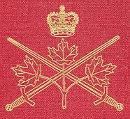 | Canadian Expeditionary Force | 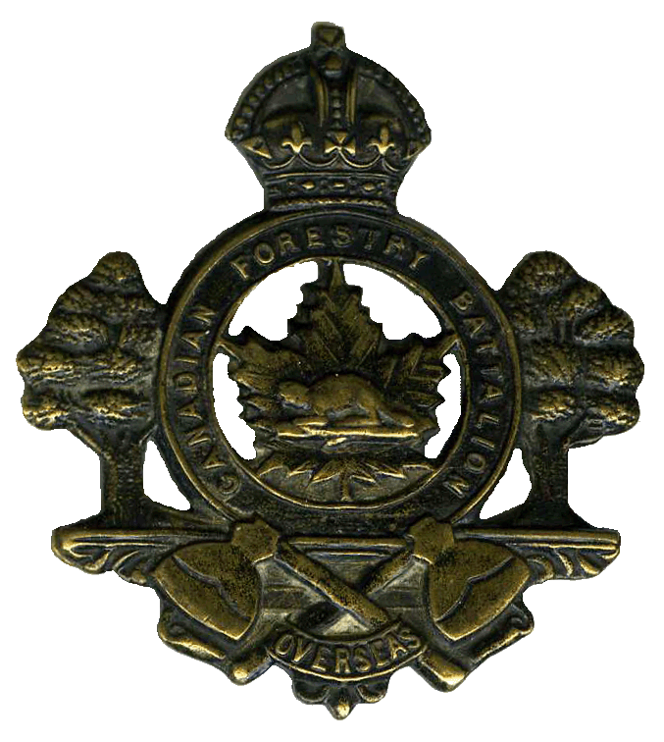

Component: | 238th Infantry Battalion

Active Dates: | July 15, 1916 to September 1, 1920

Theatre of Operations: | England and Scotland

Major Battles / Battle Honours: | The unit was not active as an infantry battalion in front line fighting.

Background:
Stewart reports that the 238th Infantry Battalion was absorbed by the Canadian Forestry Corps.
From Library and Archives Canada we find a number of items listed but none of them are available on-line:
238th Battalion, Canadian Forestry Corps.
CEFSG member Stuart has kindly provided this information for the Group:
On 11th September 1916, the 238th Canadian Forestry Battalion, with a strength of 44 officers and 1082 other ranks, embarked at Halifax and arrived at Liverpool on 22nd September. From thence it was conveyed by three trains to Witley Camp, Surrey, where training and organization were continued.
The Battalion was gradually broken up, the following moves taking place:
18th October 1916: 2 officers and 89 other ranks proceeded to Whittingham, Northumberland and 2 officers and 87 other ranks to Riddings Junction, Cumberland to prepare camps for the reception of the balance of their respective companies.
26th November 1916: 141 other ranks and officers proceeded to France to engage in Forestry Work.
2nd December 1916: 1 officer and 50 other ranks proceeded to Virginia Water, Surrey; 4 officers and 156 other ranks to Castle Douglas, Scotland; 4 officers and 25 other ranks to Bagshot, Surrey.
7th December 1916: the detachment operating at Riddings Junction was reinforced by the balance of the original company.
In December 1916, the balance of the 238th Forestry Battalion then left at Witley Camp, was transferred to the Canadian Forestry Corps and was known as the Base Details Detachment.
Scotland and England were divided into three Forestry Districts, No. 2 District (re-designated No. 52 District) being assigned to the late 238th Battalion, the Headquarters of which were moved on 6th December 1916 to Orton Park, near Carlisle, under the direction of Lieut.-Col. W.R. Smyth. In this District, operations were then being carried out at Dalston, near Carlisle; at Riddings Junction, on the Netherby Estate; at Castle Douglas, in Scotland; and at Whittingham, 35 miles north-west of Newcastle.
Lieut.-Col. W.R. Smyth, remained in charge until he was promoted on 9th September 1917, to be Acting Deputy Assistant Director of Timber Operations, after which, Major C.V. Campbell was made First in Command of this District and Major G.B. Hull, Second in Command.
I have a little detail on two of the companies derived from the 238th Battalion:
No.111 Company (formerly 'F' Coy., 238th Forestry Battalion) was based at Castle Douglas, south-west Scotland. The Company arrived on 3rd December 1916 to take over previous operations from the 224th Battalion. Captain Ramsay was in command. Other officers were Capt. J.H. Johnston, Lieuts. Jewell, Merrifield, McDonald and Leclair.
No.127 Company was formed, by authority of A.O. para. 805 D/26.9.17, from one half of No.111 Company at Castle Douglas. Situated at Jedburgh, Scotland, the advance party arrived from Castle Douglas on 4th October 1917.

